**SPH3U 12.2 Oersted’s Discovery**

1. **Oersted’s principle**

|  |  |
| --- | --- |
| Oersted’s principle: |  |
| Right-hand rule: |  |

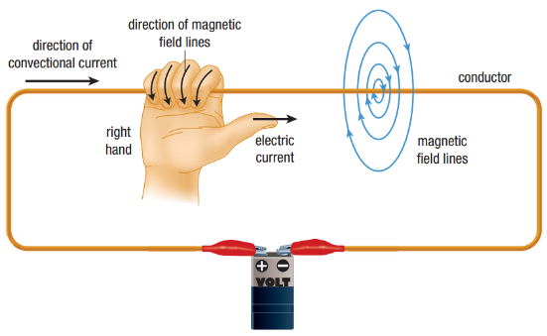

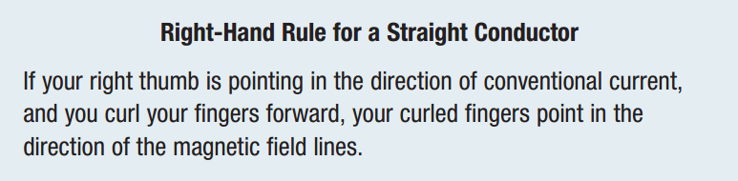

|  |  |
| --- | --- |
| Current into /out of page: |  |

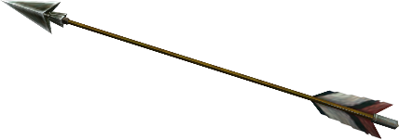 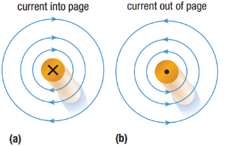

|  |  |
| --- | --- |
| Conventional current: |  |
| Electron flow model: |  |

Draw the magnetic field for each diagram.

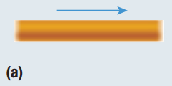 

Draw the direction of the conventional current for each diagram.

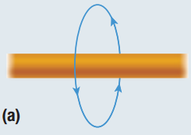 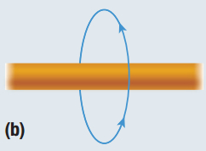 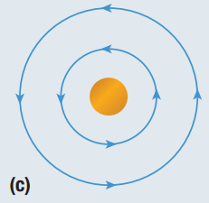

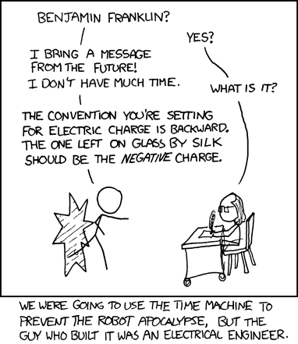

**Homework:** page 556: #1-2, 5, 7